**Phase 5**

**Lesson 3**

**Set the Storage Class of an Object**

Steps:

1. Selecting the bucket

2. Setting the storage class of an object

Step 1: Selecting the bucket

* Select the bucket and open the list of items

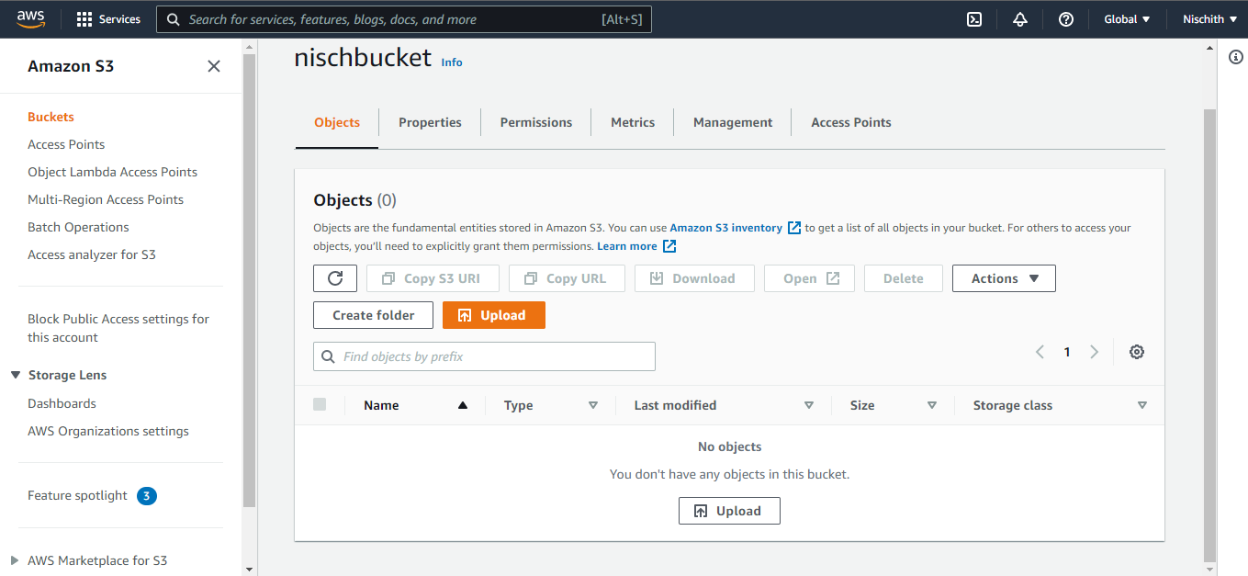

**Step 2:** Setting the storage class of an object

* Click on *Upload* and select the file and click upload

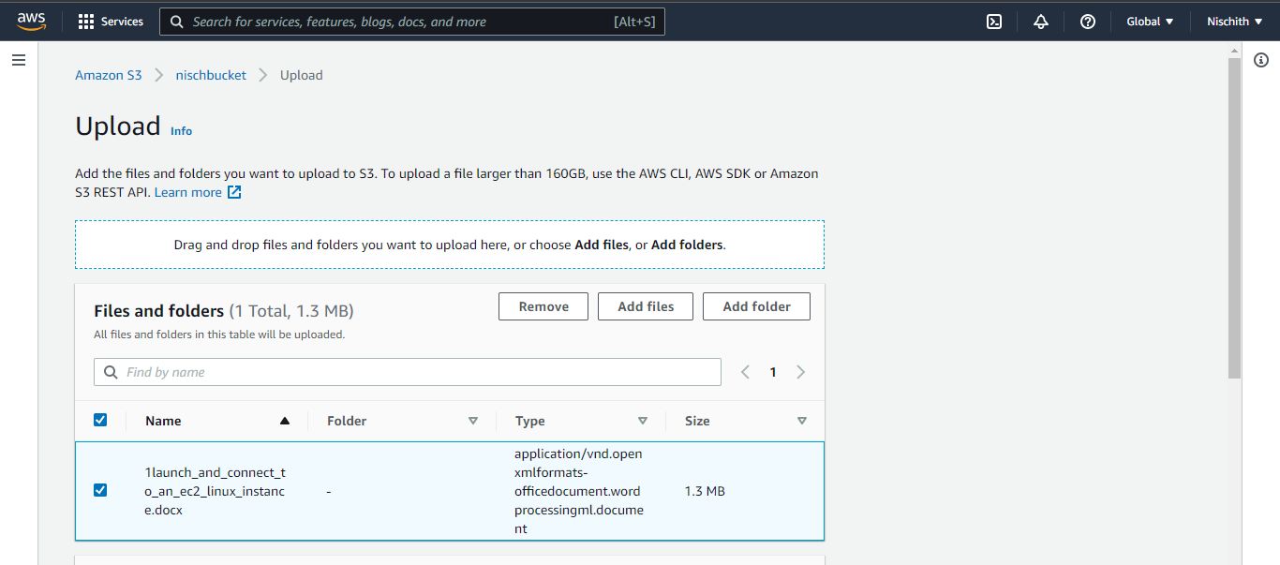

See the uploaded file to bucket:

